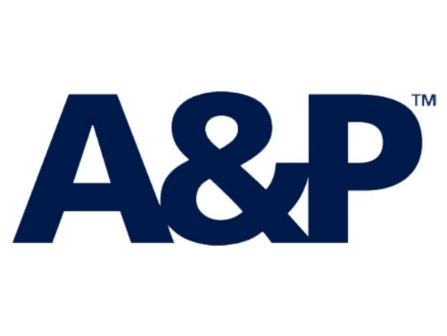

TOWAGE GUIDELINES

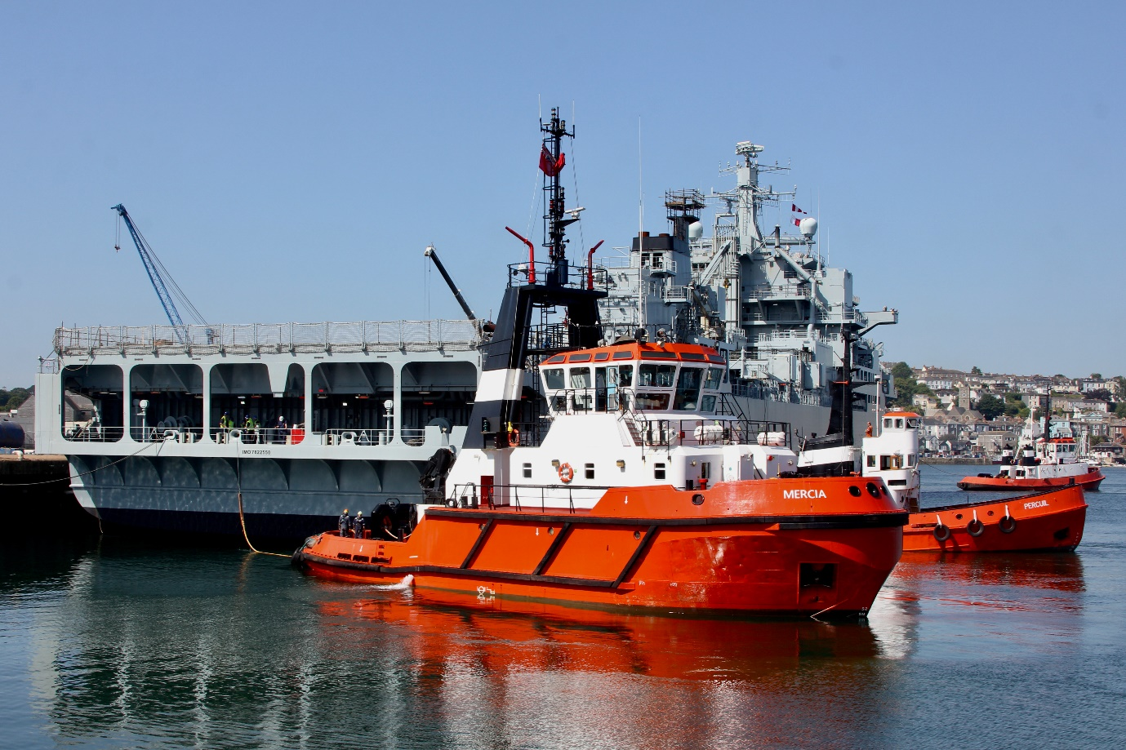
Falmouth Docks and Engineering Company
Marine Operations Department
A&P Falmouth
The Docks
Falmouth
TR11 4NR
UK
+44 (0) 1326 214 666
MOM@AP-Group.co.uk

Contents
INTRODUCTION 3
ASSOCIATED DOCUMENTS 3
PART 1 – TOWAGE GOVERNANCE 3
Towage Matrix 3
Deviation from the Towage Matrix 4
Tug/Workboat Acceptance Criteria 4
Qualifications 5
Notice and Towage Operations 5
Personal Protective Equipment (PPE) 5
Towing Equipment 5
Special Category Movements 5
PART 2 – PREPARING FOR TOWAGE OPERATIONS 7
Planning and Co-ordination 7
Pilot / Vessel Master Exchange 7
The Pilot should advise the Master 7
Pilot / Tug Master Exchange 7
Pilot / Boatmen & Linesmen Exchange 8
Preparations onboard the ship/barge/deadship 8
Preparations onboard the Tug 8
Watertight Integrity 8
PART 3 – COMMUNICATIONS 9
Communications 9
Loss of Communications 9
Master or Pilot instructions to the Tug 11
PART 4 – TOWAGE OPERATIONS 13
Introduction 13
Types of Operation 13
Standby on Berth 13
Standby in Attendance 13
On the Line / Made Fast 13
Push-Pull 13
Push Only 14
Dead / Cold Ship / Barge Move 14
Project Towage 14
Tugs Available in the Port of Falmouth 14
Tug Connection 14
Disconnecting 15
Tow Quick Release 15
Crew Safety during Towing Operations 15
Girting 15
Gob / Stopper Rope 16
Safe Speed – Conventional Tugs 17
Safe Speed – Omni-Directional Tugs 17
Interaction 18
Tow Line Length 18
Tug & Tows 18
Safety of Boatmen and Mooring Boats 18
Poor Weather 18
Towage in restricted visibility 19
APPENDIX 1 – TOWAGE MATRIX 20

INTRODUCTION
Towage is an inherently dangerous operation, and these guidelines are in place with the aim of improving safety for all involved. Falmouth Docks have records of towage incidents and near misses over the last decade that highlight just these risks. Situations can deteriorate quickly and the key aim is to avoid incidents and make sure everyone goes home safely. Between 1998 and 2024 the MAIB has published 7 investigation reports into conventional tug accidents which have resulted in 7 crew fatalities.

ASSOCIATED DOCUMENTS
AP(Pol)003(c) - HSEQMS Manual Policy (Falmouth)
AP(G)7000(c) - Falmouth Towage Assets (Falmouth)
AP(G)7001(c) - Specific Vessel Towage Allocation (Falmouth)

PART 1 – TOWAGE GOVERNANCE
Falmouth Docks and Engineering Company (FDEC), in complying with the requirements of the Port Marine Safety Code (PMSC) has identified towage as a mitigating factor to reduce the risk of certain marine operations. As such FDEC requires an adequate number of approved tugs to be available to safely support ship operations within the harbour area.

The Falmouth Docks Act 1959 includes the following provisions related to tugs and towage:
- Section 31 – authorises FDEC to own, operate and licence tugs, lighters and other ships and boats providing towage services to other vessels

These tugs must be ‘fit for purpose’, with the crews adequately trained and qualified for the tasks they are likely to perform. FDEC, as the SHA facilitates this requirement through the Tug Acceptance Criteria. Additionally, the pilots who use these tugs should be competent to do so, having been trained to agreed standards. The information in this document lays down the criteria that towage operations, their management and towage users should meet.

The purpose of this guide is to provide generic and specific instructions to the Ship’s Master, Tug’s Master and Pilot engaged in tug assisted navigation and detail the scope for using tugs as a means of reducing risk. There are two main parts to the guidelines, Parts 1 and 2 with the administrative process and Parts 3 and 4Error! Reference source not found. address the physical aspects of towage.

These guidelines have been produced after consultation with all operational stakeholders and are a minimum standard as they are used as a mitigation in the management of navigational marine risk. These Towage Guidelines will be reviewed periodically in order to ensure that they remain current.

Towage Matrix
FDEC Towage Matrix sets a baseline requirement for minimum towage for vessels bound for specific locations within the Port. Alongside the periodic review of this document, the matrix is also reviewed based on commercial traffic patterns within the Port and from Industry incidents, feedback and recommendations. The Towage Matrix is derived from the Marine Navigational Risk Assessment, vessel length, vessel type and wind speeds.

Deviation from the Towage Matrix
The Master of a vessel may consider the towage requirements in the Matrix are more or less than is needed for their vessel. The Master and Pilot(s) can discuss a towage exemption from the Matrix and the Master (or via the Agent) can request an exemption to A&P Marine/Port Operations Manager for an approval. In consultation with the Duty Pilot the Duty Operations Manager will decide to grant or deny the request.
In assessing any variation from the Towage Matrix the following points are taken into consideration:
- The berth and complexity of the manoeuvre;
- Vessel design and handling characteristics; manoeuvring aids (thrusters), type of propulsion system, type of steering system, type of main engine;
- The length, beam and draught of the vessel;
- The windage of the vessel;
- Minimum under keel clearance during the planned passage transit;
- Range of the tide on the date in question and the forecasted/live metocean conditions;
- Any reported defects;
- Availability of line handlers.

Tug/Workboat Acceptance Criteria
Below lists criteria to be met for approval for a tug/workboat to be used for assistance towage in FDEC SHA. Copies where required of below documentation should be provided to Marine/Port Operations Department prior to any tug being used.
- Tug must be fit for purpose and coded for towing operations. Where possible, the tug should be Omni-directional. Screw tugs/workboats could be considered on a case-by-case basis with particular care paid to planning the operation for safe speed and gob line arrangements - positioning these tugs/workboats in the most effective and safest position.
- Owner to provide Towing Risk Assessments – consider the tug/workboat limitations;
- Owners to provide vessel specification sheet stating tug’s maximum sustainable bollard pull certified within the last three years;
- Details of compliance to a coding body;
- Record of Qualification and Experience of Master;
- Owners/Operators emergency contact details;
- Details of Towage Equipment:
  - Specification of tow gear and equipment;
  - Relevant Certification;
  - Quick release method;
  - Gob line securing arrangements for screw tugs/workboats.
- Insurance - the Towage Operator must have in place and maintain P&I insurance for third party liability risks;
- Agreement of UK Standard Conditions for Towage 2024;
- FDEC shall be entitled to carry out a compliance check these requirements.

To assist with the allocation of Towage assets, there are two reference documents available:
- APPENDIX 1 – TOWAGE MATRIX
  - This document outlines the recommended allocation of port tugs according to the type of job (client vessel) and what towage assets are available.
- AP(G)7001(c) - Specific Vessel Towage Allocation (Falmouth)
  - This document outlines specific case studies of vessels that are frequent visitors, or with specific characteristics that may guide a different allocation of towage assets.

Qualifications
Standards of tugs and crews are set by the Maritime and Coastguard Agency in accordance with the PMSC and The Guide to Good Practice. All tugs must comply with these standards and the tugs must be safely and adequately crewed. In addition, Tug Masters are required to have experience and an understanding of the area in which they operate. Where out of port tugs are operating within the docks, if required, a local Tug Master or Pilot can be onboard to assist. Where a Pilot is provided to give local knowledge advice, they are not engaged to provide instruction on tug handling.

Notice and Towage Operations
Tugs are available in Port 24 hrs a day, 365 days a year at a minimum of 12 hours’ notice. Initial tug orders should be through a local port agency / vessel owner / operator with a minimum of 12hrs prior to required time. Note, if no port agent is appointed Falmouth Towage reserves the right to withhold Towage Services until they have received a Purchase Order.

Personal Protective Equipment (PPE)
Tug crews involved in towage operations should always:
- Wear approved and in-date self-inflating lifejackets and other appropriate PPE (e.g. hard hat, safety footwear, etc) throughout the operation;
- Ensure that the working area is safe and free from trip or slip hazards;
- Remain alert to what the ship’s crew is doing.

Towing Equipment
Towing hooks / winches and alarm bells, if fitted, should be inspected regularly. The emergency release mechanisms on towing hooks and winches should be tested before every towage operation to ensure correct operation, both locally and when fitted remotely. All towing equipment in use should be suitable for the task required, certificated and inspected for damage before undertaking and after completing a towage operation. This is especially important with gob ropes – Tug masters shall ensure they are fit for purpose and in good working order to ensure reliability. It is safety critical and will save your life.

Special Category Movements
It is recognised that due to the considerable variations in vessel size, shape, condition and degree of capability, certain vessel movements may not be adequately covered by these guidelines. In these circumstances, the vessel will be defined as a “Special Category Case” and an individual assessment of the planned movement undertaken – refer to AP(F)7014 Rev 3 - PMSC FM014 Special Category Movement Form. This is particularly pertinent when a damaged or disabled vessel is to be moved within the port.

The method for implementing a special category assessment should consist of the relevant Port Authority and the Duty Pilot completing the Special Category move form (AP(F)7014 Rev 3 - PMSC FM014 Special Category Movement Form). The completed document is then emailed to relevant distribution list. The special category acts as an assessment of the risk and the methods of mitigating such risks, which shall be firstly determined by local knowledge and experience.

Should they be required the Duty Marine Operations Manager, shall advise the details and capability of possible charter tugs available for special category move. Contingency planning shall be an integral part of the assessment. The results of the assessment shall be taken by the duty Pilot with him on the ship, to discuss with the vessels master or owner’s representative, where upon the special category assessment becomes a guide for the ship move and forms the basis for the passage plan to be agreed and discussed with the Master during the Master / Pilot exchange.

PART 2 – PREPARING FOR TOWAGE OPERATIONS

Planning and Co-ordination
A comprehensive passage plan should be prepared by the pilot and / or master, taking account of all relevant factors, including tide, wind, visibility, the ship’s size, type and characteristics, and the berth or buoy operator requirements.

A good knowledge of the type and capabilities of the tugs allocated to the job is important, in order that the pilot or master can ensure that tugs are suitable for the task ahead and positioned on the vessel so as to be most effective, and to facilitate a safe operation. Any conflict or mismatch between the required manoeuvre and the tugs allocated must be resolved before the towage operation begins.
Responsibility for co-ordinating a towage operation lies with whoever has the conduct of the vessel being towed, be that the Master, Tow Master or the Pilot.

When berthing and un-berthing, it is the duty of the master and pilot to ensure that the vessel is handled in a safe and controlled manner, having due regard to the safety of all those involved. The same standards should be applied to workboat towage operations, all workboats used in towage operations should be coded as such and Masters should be trained and familiar with towing operations

Pilot / Vessel Master Exchange
In addition to the standard information passed to the Pilot, it is recommended that the master provide the Pilot with a deck General Arrangement showing the layout and safe working load (SWL) of the mooring fittings, where known, and inform him where appropriate:
- Which fairleads, chocks, bollards and strong points can be used for towing;
- Areas of hull strengthened or suitable for pushing and relevant identification marks employed;
- Tugs towlines and pennants should be used for all towage operations;
- Any special features (e.g. controllable pitch propellors, thursters, Azimuths).

The Pilot should advise the Master
- The tug rendezvous position;
- The number of tugs and the mode of towage;
- The type of tugs to be used and their bollard pull(s);
- Maximum planned speed for the passage (no more than 6 knots for omni-directional tug, 2-3 knots for conventional screw tugs/workboat);
- The use of appropriately weighted heaving lines;
- Areas of the transit posing particular risks with respect to the possible use of the tug/workboat;
- Primary and secondary VHF channels for use in the operation.

Pilot / Tug Master Exchange
The Pilot and Tug master should discuss the following:
- The tug connection point, taking into account the prevailing weather and sea conditions;
- Passage details while accompanied by the tug(s), particularly details of any swing/berthing manoeuvre, release position and any abort points and procedures as required;
- Any unusual items regarding the particular vessel as gleaned from the Master/Pilot exchange;
- Any failure or reduction in the tug’s ability to manoeuvre or deliver full bollard pull;
- SWL of bollards intended to be used;
- Tug Master should confirm the available method for releasing a line under load (i.e. hook, emergency brake release, mechanical or manual cutting).

Pilot / Boatmen & Linesmen Exchange
All personnel involved in the mooring operation should be aware of the special considerations required namely:
- Awareness of the mooring boat’s position;
- Tugs and vessels should not manoeuvre unexpectedly;
- Required position for running lines and what lines require running.

Preparations onboard the ship/barge/deadship
Tug operations impose very great loads upon ropes or warps, gear and equipment. The Code of Safe Working Practices for Merchant Seamen sets out certain precautions which should be taken. Sudden failure in any part of the system may cause death or serious injury to personnel.
The consequences of failure in any part of the system must be carefully considered and effective precautions taken. On-board ship, particular attention is drawn to the need to ensure that pedestal roller fairleads, lead bollards, mooring bitts and posts etc are:
- Used appropriately within their design capabilities;
- Correctly sited;
- Effectively secured to a part of the ship’s structure which is suitably strengthened.

Sufficient crew should be provided to ensure that individuals are not exposed to undue risk, and that the operation can be conducted safely and efficiently. Equipment such as heaving lines and messengers should be of appropriate length and strength. All equipment should be checked before the start of each operation.

Preparations onboard the Tug
Tug Masters are to ensure that all onboard pre-departure checks are completed before getting underway, all crew are fit and appropriately rested, adequately trained for the operation and wearing correct PPE.

Watertight Integrity
The watertight integrity of the tug should be maintained at all times. When a tug is engaged on any towage operation all watertight openings should be securely fastened. All watertight openings should be marked with a sign stating that they are to remain closed during towage operations. Any such openings used whilst moving about the tug during a towage operation should be re-secured immediately after use.

PART 3 – COMMUNICATIONS

Communications
ANY UNCLEAR MESSAGES SHOULD BE QUESTIONED
Tug Working Channel VHF 11 with secondary channel VHF 74
VHF communications are a vital component of safe towage operations. It is essential that those on board the ship, the tug(s), mooring boats, and those on the shoreside, are able to communicate promptly throughout the towage operation, should the need arise.
Once VHF communications have been established, tested and pilot/tug master/linesmen information has been exchanged, personnel should keep transmissions to a minimum and should normally only call when in doubt, to confirm actions, give pertinent information or in an emergency.
Mooring personnel should monitor the tug/ship VHF working channel to have a proper appreciation of progress in the mooring operation.
In all communications clear identification of the parties communicating must be used to prevent misunderstanding. The Tug master should be kept informed of large alterations of course and standard Marine Communication Phrases (SMCP) should be adopted to aid communication. Pilot Instructions to the Tug should be clear, concise and follow convention. Instructions should be acknowledged by the Tug Master.

Loss of Communications
In the event of loss of communications, the emergency means is via whistle signals. The following whistle signals are to be used between the tug and tow until VHF communications can be re-established.
Signals to or from a towing vessel ahead:
- Tow ahead – one prolonged blast followed by three short blasts;
- Tow to port bow – one prolonged blast followed by two short blasts;
- Tow to starboard bow – one prolonged blast followed by one short blast;
- Cease tow – one prolonged blast followed by six short blasts in succession.

Signals to or from a towing vessel astern:
- Tow astern – three short blasts;
- Tow to port quarter – two short blasts;
- Tow to starboard quarter – one short blast;
- Cease to – six short blasts in succession.

Signals to all towing vessels:
- Hold in position – one prolonged blast followed by one short blast followed by one prolonged blast followed by one short blast;
- Let go – one prolonged blast followed by two short blasts followed by one prolonged blast.
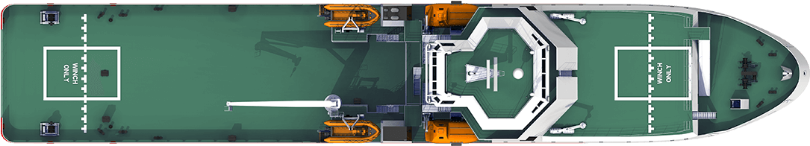
···

­···
­·

·

­··

·····
All aft tugs stop

··

­·····
All fwd tugs stop

Emergency Whistle Signals

Signals for all tugs
­·­· = Hold in position
­··­ = Let go or knock out (also from tug to ship)

Master or Pilot instructions to the Tug
To avoid confusion and errors, Pilots will ask for tug power and directional requirements as follows.
The power required will be indicated as percentages:
100% | Full
75% | Three Quarters
50% | Half
25% | One Quarter
“Minimum” or “Easy” or “Tight Line” | Line is just tight visibly or gear is simply just engaged when leaning on for a push.
“No Weight” or “All Stop” or “Slack Line” | Line is visibly slack (not in the water) or tug is holding position/barely touching the ship side ready for a push.

The direction of pull will be indicated as shown below:
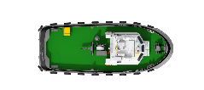
Astern
Ahead
Starboard Bow / Shoulder
Starboard Beam
Starboard Quarter
Port Bow / Shoulder
Port Beam
Port Quarter

Compass points, known land marks or position relative to the ship/towed vessel should be used when issuing orders to tugs.
Personal names should not be used to communicate, vessel’s names, or move specific call signs should be used.

PART 4 – TOWAGE OPERATIONS

Introduction
This section seeks to provide guidance on ship towage practices as used in Falmouth, the guidance draws upon nationally documented towage best practice and additionally identifies those towage procedures specific to Falmouth. They should be read in conjunction with the British Tug Owners Association Pilot’s Pocket Guide and Checklist.

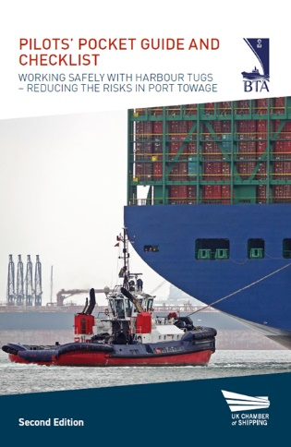

Types of Operation

Standby on Berth
Standby on berth means the tug is fully manned with engines running, lines singled up ready for a fast departure should the vessel require the tug at short notice. The tug should be prepared to make fast, or push-pull at the Pilots/Masters discretion.

Standby in Attendance
Standby in attendance means the tug is fully manned, off the berth and in close attendance to the vessel if they are required at short notice. They should be prepared to make fast, or push-pull at the Pilots/Masters discretion.

On the Line / Made Fast
‘On the line’ towing means the tug is connected to the assisted vessel by a towline normally made fast on or close to the centre-lead forward or aft. The towline is connected to the tug by a towing hook, winch or secured to the towing bitts.

Push-Pull
The push-pull operations means that the tug is connected to the assisted vessel by a tow line and remains in close proximity to the vessel. This enables the tug to push on the vessel, but then check/control the vessel by pulling-back on the tow line.

Push Only
Push only operations mean the tug remains in close proximity to the vessel, positioned in a manner to push on the vessel where required as per the direction of Master or Pilot.

Dead / Cold Ship / Barge Move
A dead ship is defined as a vessel in a condition under which the main population system and auxiliaries are not in operation due to the absence of power. Towing barges and dead ships by their nature require careful consideration and as such are subject to a non-routine towage form if moving between harbour areas which may also result, or be subject to an individual risk assessment (Special Category Move).

Project Towage
Unique vessels and/or cargo which require advanced, in-depth consultation with A&P Marine Operations department.

Tugs Available in the Port of Falmouth
Falmouth Towage, a subsidiary of A&P Falmouth provides a Harbour Towage service to vessels in Falmouth and Truro out to Falmouth Pilot Station. Vessels can operate further by arrangement, tugs are manned and maintained to MCA standards, meeting the required National Standards. All harbour towage in the Port is undertaken under UK standard conditions of towage, 2024.
- Additional 3rd party vessels are sourced from outside the port, which are detailed in AP(G)7000(c) Rev 1 - Falmouth Towage Assets (Falmouth)

Tug Connection
Before arrival at the tug connecting position, the pilot or master should establish effective communications with the tug(s) and agree working channels. The vessel’s speed should be reduced to that which allows a safe rendezvous and connection with the tug(s). The required speed should be agreed in advance with the tug master involved. Before commencing a tow the tug master should determine which towing gear is suitable for the operation and instruct the crew accordingly.
When receiving heaving lines, the tug crew should be aware of the risk of injury through being struck by a ‘monkey’s fist’ or other weighted object attached to the line. The ship’s crew should, wherever possible, agree with the tug crew the area where the heaving line is to be thrown, to allow the recipients to move clear. When connecting to a tow, the tug crew should ensure that the towing gear is clear of any obstructions, able to run freely and is released from the tug in a controlled manner. The ship should not test the bow or stern thrust controls / ships whistle at the time when the tug is under the bow or stern passing up a line. Deck lights maybe required to be reduced to allow the tug to make a safe approach.
- The Pilot or Master should maintain radio contact with the tug throughout the process;
- He should be ready to revise the intended tug position if the tug master reports any restrictions at the chosen position, e.g. large flare, overhanging anchor or unsuitable push up point. The pilot or master must keep all those involved appraised of any changes to the agreed plan;
- The Pilot should always advise the tug master before making headway on the vessel, allowing the tug to move to a suitable position for towing while making way. The positioning of tugs on a vessel is a matter for discussion between the pilot/master and the tug master(s), having full regard for the areas of the hull, which should be avoided, e.g. watertight doors, between frames etc;
- If the tugs are made fast alongside or pushing they are at their most effective with a minimal ship speed through the water.

Disconnecting
During disconnection, both the vessel’s and tug’s crew on deck should be aware of the risk of injury if the towing gear is released from the tow in an uncontrolled manner and avoid standing directly below. They should also be aware that any towing gear which has been released and is still outboard may ‘foul’ on the tug’s propeller(s), steelworks or fendering, causing it to come tight unexpectedly. The towline should always be lowered onto the tug deck, never just ‘cast off’ and left to run.

Tow Quick Release
The emergency release mechanism on winches and towing hooks should be tested both locally and where fitted remotely. All methods of tripping or run out are to be tested with consideration given to testing under load. Correct maintenance and operation are essential. Under no circumstances is towing equipment to be connected to any winch or hook that has a suspect release mechanism.

Crew Safety during Towing Operations
Once the towing gear is connected, the ship’s crew should indicate this to the tug crew and then clear the area and, if required to remain on deck, stand in a safe position.
If the crew are required to attend the towing gear during a towing operation, the length of time exposed should be kept to a minimum and the associated Tug Master should be informed. During towage operations the towing gear equipment and personnel should be continuously monitored and any change in circumstances immediately relayed to the pilot.
This is particularly important on tugs where the tug master has a restricted view of the towing area/ personnel. Crew should be aware that the tow may have to be released in an emergency situation.

Girting
Masters, Pilots and Tug Masters must have a clear understanding of girting and its consequences. Girting happens when the towline is secured amidships off a tug/workboat and leads of the beam at right-angles to the tug/workboat. If that line comes under tension then a heeling movement on the tug is exerted which can overcome the righting lever causing it to girt. This can lead to deck-edge immersion, flooding and potentially capsize.
Conventional tugs are particularly vulnerable to girting due to their relative lack of manoeuvrability. Omni-directional tugs such as ASD or Voith have integral anti-girting design due to positioning of the towing points or other design features.
Common causes of girting are:
- The assisted vessel turns abruptly without warning away from the screw tug/workboat;
- The speed of the vessel is too high;
- The tug is too far astern of its intended position, compared to the speed of the vessel;
- Incorrectly rigged Gob line.

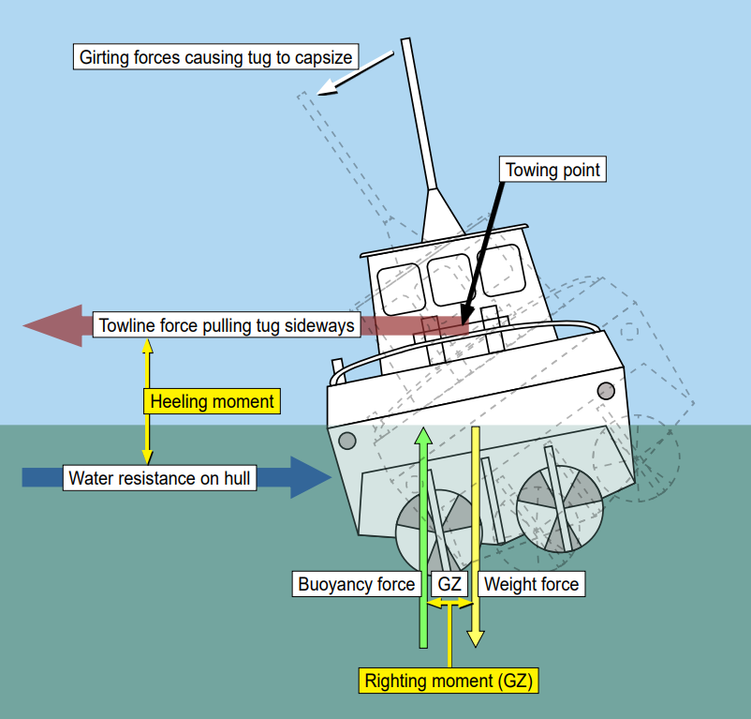

Gob / Stopper Rope
A suitable gob rope or wire should be used where it is identified that a ‘girting’ situation may arise. It is deemed compulsory for gob lines to be rigged by conventional tugs/workboats in an effective way. A conventional tug towing on the bow may need a gob line rigged differently to a conventional tug on the stern, towing stern to stern.

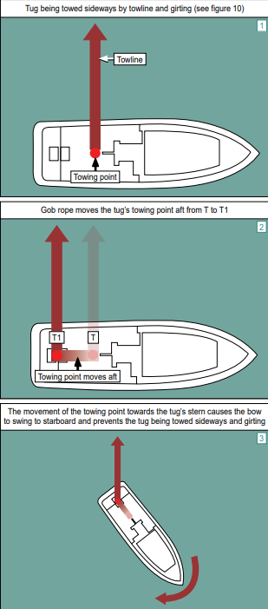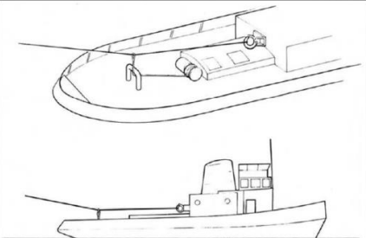

Safe Speed – Conventional Tugs
When making fast and letting go a conventional tug, speed and the orientation of the tug are critical factors. The maximum planned speed for the passage should not exceed 3 knots with conventional screw tugs.
Most ship towage manoeuvres should be carried out with the minimum of way on the ship. Exercising caution when using the engines while the tugs are working. The aft tug will be affected by the wash and every tug will be affected by the change of speed either up or down, and a rapid change in speed is all the worse. The Pilot needs to ensure the vessel’s speed through the water is steady and caution must be exercised when using the engines whilst the tugs are working. If the situation dictates the use of the engines, the minimum that the situation allows should be used and the tugs should be informed of what the ship is about to do as it will affect their own actions.

Safe Speed – Omni-Directional Tugs
The maximum planned speed for the passage should not exceed 6 knots with omni directional tugs.
Some speed is required at times, the tugs generally like to have less than 5 knots through the water. This normally gives them the necessary way to assist them to manoeuvre close to the ship while it gives them plenty of power in reserve should they have to break away.
The following figure gives an indication for effective vessel speeds against direction of where an omni-directional tug can effectively work. This is because the tugs power is redirected to move the tug sideways through the water at the same speed of the ship, reducing their ability to effectively tow the ship in question in the direction of travel for the tug.
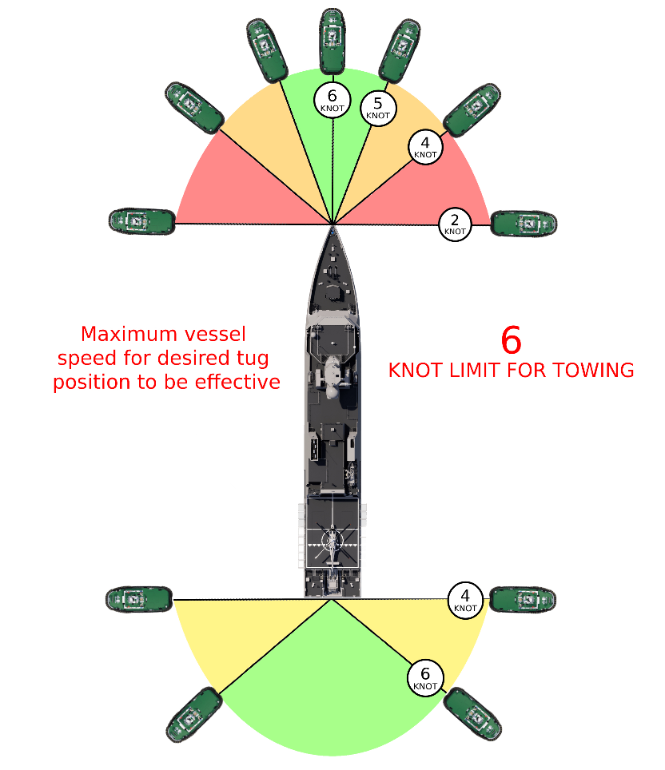

Interaction
Interaction and its effects on the tug and its handling are well known and appreciated in harbour towage. Pilots, Masters and Tug Masters are reminded that these effects are multiplied as the vessel’s speed increases. Areas of high and low pressure exist in and around the ship’s hull and these areas can cause adverse movements of smaller vessels in close proximity. The Pilot and Tug Master should be aware of the effects of hydrodynamic interaction and the effect it may have on the tug – MGN 199(M) – Dangers of Interaction – provides further guidance and information on the effects of interaction.

Tow Line Length
When towing on a line a Tug Master determines the tow length based on their experience – this depends on factors such as length of tug, ship speed, size and deck height of the ship to be assisted, environmental conditions and available manoeuvring space for the tug. Safety is paramount and Tug Masters should carefully consider the towline length for a forward tug assisting a ship under speed. If using a short towline, the distance is reduced between the tug and ships bow resulting in less time for a Tug Master to react to course and speed changes. Master a Pilot must ensure that they are careful with engine and rudder movements and keep the Tug Master well informed about upcoming changes to speed or turns.

Tug & Tows
The majority of this document is aimed at towage assistance operations for arriving and departing ships. However, there are occasions when towage occurs which is not specifically identified in this guide such as barge towing. Whenever there is a need to conduct this type of operation in the harbour area then a non-routine towage form (AP(F)7013 Rev 1 - PMSC FM 013 Application for Towage Operation) is to be completed and submitted to the Marine Operations Department for approval.

Safety of Boatmen and Mooring Boats
Tug Masters, pilots and masters should be aware, at all times, of the position and intentions of mooring boats, especially in adverse weather conditions. This is particularly important in circumstances where visibility is limited from the tug wheelhouse and ship’s bridge. Remember that bow and stern thrusters, and the wash from tugs and the vessel being assisted, can all cause significant problems for mooring boats, especially when they are in close to the vessel and/or tug(s) picking up and running with lines. Controllable pitch propellers are a separate, but equally dangerous hazard. When running aft breast or stern lines, the Pilot/Master should never use the vessel’s engines without confirming with the Linesmen as to the position of the mooring boat.

Poor Weather
During periods of poor weather, Falmouth Docks and Engineering Company’s Duty Marine Operations Manager or their deputy, may board vessels alongside to discuss with Vessel’s Master, mooring arrangements and the use of tugs to keep the vessels safely berthed.

If there is likelihood that the weather conditions may pose a significant risk to the Tug Crew/Tug/Towing Gear, the Tug Master should immediately inform the Pilot/Master of any concerns that he may have. The Pilot and Tug Master should take immediate action to ensure the safety of the assisted vessel/tug/tug crew and, if necessary, the operation aborted as soon as it is safe to do so.

Towage in restricted visibility
Towage during restricted visibility should be avoided. Preferably postponed until conditions improve. Guidance from FDEC’s Restricted Visibility Procedure should be adhered to.

APPENDIX 1 – TOWAGE MATRIX

General Notes

Below tables are based on minimum available tug bollard pull (St Piran 20T BP), with a maximum of 20knts wind speed (sustained) unless otherwise stated, for movements above this criteria a discussion between the Duty Marine/Port Operations Manager and the Duty Pilot should take place to ensure a review prior to the move.

The tables are based on minimum requirements compiled for conventional vessels of varying length and manoeuvring aids, taking into account the forces likely to be exerted by wind, current and wave action along with industry best practice and have been subject to independent review from a subject matter expert. These tables are subject to review and should be considered in conjunction with any port infrastructure changes.
In addition to this base line criteria, there are numerous other factors which need to be included in the overall assessment of tug support. This is to include but not limited to:
- Vessel Draft, Weather Forecast, Predicted Tide, Sea State, Vessel defects / damage, Berth, Orientation on Berth, Sea Room available, Vessel Windage

It should be noted however, that in cases where the vessel’s Master refuses to accept the Duty Marine/Port Operations Manager and Pilot’s advice in respect of the number of tugs required to facilitate a safe operation, the Duty Marine/Port Operations Manager may impose the required number of tugs by special direction. These tugs will be charged to the ship owner/Agent.

Allocation requirements
- Vessels that are underway carrying DPG cargo in excess of 100m LOA within FDEC SHA will require a minimum of 1 x tug in attendance;
- All passenger vessels in excess of 100m LOA are to have a tug on short notice standby from lighthouse to berth or visa versa;
- Vessels with special requirements, i.e. high speed ferries may substitute tugs for workboats due to bollard SWL and construction but this would be based on special category review and discussion with Master, Duty Marine/Port Operations Manager and Pilot;
- Based on specific ships handling characteristics or history at the Duty Marine/Port Operations Manager and Pilots discretion, towage allocation can be increased based on experience in handling of that or sister vessel’s of the same class. The list of these vessel’s will be available from the Marine Operations Department on request;
- The Duty Marine/Port Operations Manager or Tug Master reserves the right to withdraw the offer of towage services where the weather conditions /swell height pose a significant risk to tug crews. There could be occasions where this could delay arrival or departures of vessels;
- Reference Specific Vessel Towage Allocation table to check for specific allocations that fall outside of generic vessel allocations.

Terms
SNS = Short Notice Standby. Tug, crewed with engines running on its berth
WB = Workboat
Dead Ship = Vessel has limited or no propulsion and/or defective manoeuvring systems.

Table 1

Roads to Docks Berth, visa versa
Based on no more than 20knts of wind – Above this the Pilot and Marine Operations Manager should agree in advance of pilot boarding

 | <20m to 49.9m | 50m to 99.9m | 100m to 119.9m | 120m to 149.9m | 150m to 169.9m | 170m to 199.9m | 200m to 249m
Dead Ship or ship with defect | Special Category Move | Special Category Move | Special Category Move | Special Category Move | Special Category Move | Special Category Move | Special Category Move
Single screw (No Thruster) | 0 | 50m to 75m = 0  76m to 99.9m =  1 WB SNS | 1 | 2 | 2 | 3 | Special Category Move
Single screw with enhanced rudder + Bow Thruster | 0 | 0 | 1 | 1 | 2 | 2 | Special Category Move
Twin Screw / Enhanced twin rudder & Bow Thruster | 0 | 0 | 0 | 0 | 0 | 0 | 0
Twin Screw / Azimuth Propellers / Voith, Enhanced twin rudder & Bow Thruster + Stern thruster (DP) | 0 | 0 | 0 | 0 | 0 | 0 | 0

Table 2
Roads / Berth to Docks Drydock
Based on no more than 20knts of wind – Above this the Pilot and Marine Operations Manager should agree in advance of pilot boarding

 | <20m to 49.9m | 50m to 99.9m | 100m to 119.9m | 120m to 149.9m | 150m to 169.9m | 170m to 199.9m | 200m to 249m
Dead Ship or vessel with defect | Special Category Move | Special Category Move | Special Category Move | Special Category Move | Special Category Move | Special Category Move | Special Category Move
Single Screw (No Thruster) | 0 | 1 tug + 1 WB | 1 tug + 2 WB’s (unless suitable towage can be taken into the dock) | 3 tugs + 1 WB  (unless suitable towage can be taken into the dock) | 3 tugs + 1 WB | 3 tugs + 1 WB | Special Category Move
Single screw with enhanced rudder + Bow Thruster | 0 | 0 | 1 | 1 | 2 | 2 | Special Category Move
Twin Screw / Enhanced twin rudder & Bow Thruster | 0 | 0 | 0 | 0 | 1 | 2 | Special Category Move
Twin Screw / Azimuth Propellers / Voith, Enhanced twin rudder & Bow Thruster + Stern thruster (DP) | 0 | 0 | 0 | 0 | 1 | 1 | Special Category Move

Table 3

Docks Drydock to berth / Roads
Blue – With no work being undertaken on any propulsion or manoeuvring systems inc thrusters and steering
Red – With work carried out on any propulsion and or manoeuvring systems inc thrusters and steering
Black – Allocation applies for all scenarios
Notes - The below requirements are set as a minimum of what would be required to hold the ship should equipment fail, until such time that the required amount of towage assets could be mustered to move the ship to a place of safety. Should the vessel be able to undertake a complete set of function tests prior to undocking refer to Blue allocations (successful basin trials prior to sailing).

Based on no more than 20knts of wind – Above this the Pilot and Marine Operations Manager should agree in advance of pilot boarding
 | <20m to 49.9m | 50m to 99.9m | 100m to 119.9m | 120m to 149.9m | 150m to 169.9m | 170m to 199.9m | 200m to 249m
Dead Ship or vessel with defect | Special Category Move | Special Category Move | Special Category Move | Special Category Move | Special Category Move | Special Category Move | Special Category Move
Single Screw (No Thruster) | 0  1 WB | 1WB  1WB + 1 SNS | 1 | 2 | 2 | 3 | Special Category Move
Single screw with enhanced rudder + Bow Thruster | 0  1WB | 0  1WB + 1 SNS | 1 | 1 | 2 | 2 | Special Category Move
Twin Screw / Enhanced twin rudder & Bow Thruster | 0  1WB | 0  1WB | 0  1 | 0  1 | 1 SNS  1 | 1 SNS  1 + 1 SNS | Special Category Move
Twin Screw / Azimuth Propellors / Voith, Enhanced twin rudder & Bow Thruster + Stern thruster (DP) | 0  1WB | 0  1WB | 0  1 SNS | 0  1 SNS | 0  1 SNS | 0  1 SNS | Special Category Move

