FALMOUTH DOCKS & ENGINEERING COMPANY

and

A&P FALMOUTH LTD

NOTICES TO VESSELS

IN EMERGENCY CALL

A&P MAINGATE +44 (0) 1326 214889 / 212100

Emergency phones are located on the wharfs and automatically dial the number for Main Gate upon picking up reciever

A copy of this document should be kept on the bridge or point of access for duration of stay at Falmouth Docks

A&P Falmouth Ltd
The Docks
Falmouth
Cornwall
TR11 4NR
Tel: 00 44 (0)1326 212100
e-mail: falmouth@ap-group.co.uk

INTRODUCTION

This document aims to provide information to vessels berthed or dry docked at Falmouth Docks about safety, security and environmental requirements to ensure a co-operative approach to planned activities and emergency situations.

A&P expect the Master and crew of all vessels to adhere strictly to all requirements and to co-operate in all procedures throughout their stay in Falmouth. For their part A&P will ensure that our personnel co-operate fully with the crew in the mutual interest of safe and efficient operations.

The Master is required to read this document and brief his crew on its contents. The Master must then complete the pro forma at the back of the document undertaking to comply in all respects.

If any further clarification is needed or you are unable to comply with any section of the document, please make request through the Marine Operations Manager or the Ship Manager.

Falmouth Docks & Engineering Company is a Statutory Harbour Company / Competent Harbour Authority with
responsibility for Falmouth Docks and its surrounding waters.

CONDITIONS OF BERTHING AT FALMOUTH DOCKS

POC - Port Operations Department +44 (0) 1326 214 666 - mom@ap-group.co.uk

Falmouth Docks and Engineering Company (FDEC) is the Statutory and Competent Harbour Authority for the immediate area around Falmouth Docks as laid down in the Docks Act of 1959, as shown below by the area inside the inner orange lined box. The middle and outer lines show the extended area where Falmouth Docks byelaws take primacy for vessels approaching Falmouth Docks.

The Port is managed by the use of Byelaws, Harbour Directions and Special Directions as required.

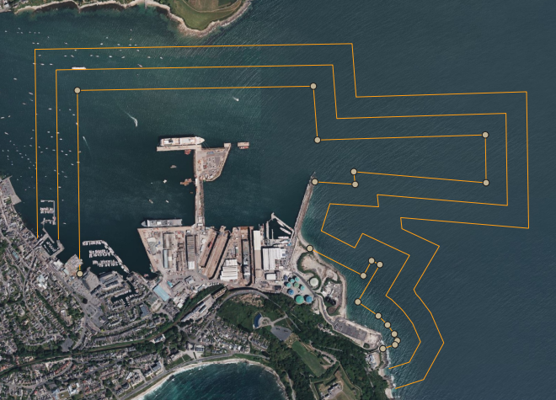

The below list of conditions of berthing should be complied with at all times, should the Master not be able to comply could result in the issuing of a Special Direction to the Master of that vessel.

- No Person Shall move any vessel within the Docks without permission of the Duty Port Operations Manager.
- Every Vessel entering or leaving the docks or moving within the docks shall have on board and in charge a competent person and sufficient crew for the vessel’s safe navigation.
- The Master of every vessel entering the Docks shall proceed to the berth allotted to them by the Duty Port Operations Manager and the Master of every vessel in the docks shall obey all such orders as to mooring, anchoring, placing, loading, unloading or moving the vessel as maybe given by the Duty Port Operations Manager.
- Vessels about to enter the Docks must have their anchors cleared and ready to let go, all projecting gear got in, good and sufficient warps and check ropes in readiness.
- No person shall work the engines of any vessel in the docks for trial or cause the same to be so worked without the permission of the Duty Port Operations Manager. Propulsion trials are permitted alongside at the discretion of the Duty Port Operations Manager. Risk mitigations must be in place prior to trials, these will include, fendering, gangways removed or out of bounds, Linesmen. Due to lines under load this may also involve the adjacent wharf to the ship being put out of bounds. Other vessel traffic and proximity will be considered prior to granting permission to undertake the trials. Minimum notice period for basin trials is 24hrs.
- Owners/Management/Masters wishing to disable/layup/cold ship their vessel alongside FDEC’s berth must seek permission from the Port Manager to do so, submitting the ‘FDEC Laid-Up Vessels - Marine Planning Document’ for review.
- Mooring analysis/plan must be submitted to the Port Manager for review and where weather conditions exceed the design specifications of mooring lines, fixtures and fittings additional mitigations such as stand by / push up tugs should be engaged to keep the vessel secured safe alongside, maintaining safe access and reducing the risk of break out to ALARP.
- When considering the required bollard push of tug(s) the below formula can be of use:
  - 0.08 x A x V2, A = Windage Area of the vessel in M2, V = wind Speed in m/sec. Tugs should not be calculated at their maximum bollard pull. 75% of max bollard pull is accepted. Wind/surge direction can vary this requirement, the port can be exposed from wind from the South East round clockwise to North West.
- Every Vessel in the docks shall have at least one competent person on-board at all times, unless otherwise agreed with the Duty port Operations Manger
- In accordance with MGN564, Marine Casualty’s and Marine Incidents are to be reported to the MAIB, with Port Operations notified as such (mom@ap-goup.co.uk), to make reporting in parallel as the Statutory Harbour Authority, as required by MGN564.
- In accordance with the Code of Safe Working Practices for Merchant Seafarers (COSWP) 2024 and MGN 533; The Master of every vessel (or designated person) alongside shall cause all gangways and stages used for the purpose of access to such vessel to be placed in a safe position, duly protected, securely fastened and to be so maintained at all times. Where ship repair personnel require access, this may involve fitting a number of yard gangways which may require modification to ships deck fittings to accommodate.
- Approved Harbour Tugs are available on request from the Port Manager, no guarantee is given of port tugs being available and may need to be brought in from external providers. All tugs and towage operations taking place in FDEC’s Harbour Area must be approved by the Port Manager.
- The Dockyard can supply Yokohama fenders for the ship on request. Once the ship is secured alongside, the Master is responsible for ensuring the fenders are monitored and should the fenders come out of position it is the Masters responsibility to inform the Port Operations Dept.
- The berthing shall be entirely at the vessel's own risk and the owner shall indemnify the Falmouth Docks & Engineering Company against any damage whatsoever, whether to the vessel, wharves, other vessels or ancillary equipment or to any person or property in respect of or arising out of the taking up or occupation or leaving of the berth.
- The permission to visit hereby granted is subject to the convenience at all times of the Falmouth Docks & Engineering Company and may be withdrawn at any time. The vessel may be required to be removed to another berth, and such movement shall be at the expense of the ship owner.
- The Master must ensure all Port arrival information is supplied in advance, this will include, Copy of Ships Fire Plan, Crew list, CERS.
- A diving permit must be issued from the Port Operations Department prior to diving operations within Docks Waters
- Bunkering is available in the Port by Barge and Road Tanker, contact the Port operations Department to raise a permit. There is a limitation of 25mt per vessel per visit, if the bunkers are not provided by World Fuels affiliated companies.
- Any vessel leaving A&P Dry Dock facilities that has had work undertaken on its propulsion, steering and / or thrusters could be subject to compulsory towage assistance. Refer to the Port Operations Department for further information
- At all times while the vessel is in occupation of the berth: -
  - No oil of any description shall be discharged into the harbour.
  - No refuse shall be discharged into the harbour, and the Master or other person in charge of the vessel shall make proper arrangements for the disposal of waste from the vessel.
  - If waste or hazardous material (including oils in containers) are required to be unloaded from the vessel, The Master must seek approval from the Port Operations Manager in advance.
  - Any material landed to the wharf must be clearly marked with the material details, safety information including COSHH data and the name of the ship and the relevant contact details.
  - In order to comply with EU Directive 2005/33/EC all vessels must change over to fuel oil with a maximum sulphur content of 0.1% m/m as soon as possible after arrival.
- The owners shall accept responsibility for the conduct of the crew and/or the watchman on board the vessel.
- All vessels capable of carrying DPG will be subject to inspection and approval by the Falmouth Docks & Engineering Company Chemist before arrival. Such vessels should normally be gas free.
- The integrity of moorings shall be the sole responsibility of the on-board competent person.
- When a vessel is dry docking, the Master and crew will be expected to take instructions from the Docking Controller to position the vessel and the crew must remain at their stations until they are stood down by the Docking Controller. Once the dock is dry there must be no discharges to the dock without the express permission of the Ships Manager.
- Falmouth Docks is in close proximity to the town of Falmouth and Flushing, Masters must be considerate to these communities and keep noise to a minimum, ships may be required to run on shore power, shore generators or shut down if the machinery noise levels are too high and become a noise nuisance to the community. Any costs associated to this will be to the vessel’s Master. Any vessel failing to comply with this may be asked to leave the Dockyard.
- Vessel’s using Falmouth Docks should keep smoke discharge to a minimum during their stay, vessel’s that continually discharging smoke, may be asked to stop their machinery or go over to a shore-supply. Any cost associated with this will be to the vessel’s Master. Any vessel failing to comply with this may be asked to leave the Dockyard.

GENERAL SAFETY

POC - Falmouth Safety Team +44 (0) 1326 214883 - falmouthsafety@ap-group.co.uk

A&P Falmouth are committed to ensuring the highest standard of Health and Safety at work for their employees and fully expect Ship’s staff to co-operate with A&P Policies when required.

In order to maintain a safe working environment for all please ensure that:

- All personnel attending the site should have undertaken the online site safety and covid induction
- RAMS All work to be performed by ships staff and sub-contractors should be approved by the Safety Department prior to the work commencing and all works must be undertaken in accordance with HSE and Maritime Guidance (COSWP).
- Hot Work is not permitted on-board the vessel unless authorised. The Company Chemist will inspect the area and issue a certificate before work can commence.
- Smoking in the facility is only permitted in designated areas (see site plan) at lunch breaks. (1200-1230Hrs & 2000-2030Hrs).
- Confined Spaces. Entry into confined spaces is not permitted until the space has been issued with an ‘Entry Certificate’ by the Company Chemist. Ship’s crew / contractors removing tank lids must place a ‘No Entry’ tag at the entrance and suitable edge protection in place. Tags can be obtained from the Company Health & Safety Officer.
- First Aid. If required First Aid can be called by dialling ext. 4444 or +44 (0)1326 214889. The First Aid post is the Main Gate Police.
- Working at Height. All personnel working at heights must be suitably protected by adequate staging and / or a safety harness with restraint lanyard.
- PPE. A&P operate a compulsory head, eye and footwear protection policy for all employees, ships staff and sub- contractors whilst working in the shipyard, you will not be expected to wear PPE when transiting the yard safe route to leave the facility.
- Asbestos. Any work with asbestos containing materials must be notified, managed and controlled in accordance UK HSE Regulations.
- Lifting. Ship’s crew and contractors are not permitted to use any Company lifting equipment or machinery without authorisation by A&P Falmouth. Ships equipment must only be used if it has undergone suitable testing / inspection. Records must be made available to A&P Falmouth on request.
- Reporting of Incidents. A&P actively encourage the reporting all safety and environmental incidents / accidents / near misses to the safety department. HSEQ Observation card books are available from the Health and Safety Department.
- Lifejackets. Lifejackets are compulsory when working within 2 metres of an unprotected edge on all wharfs and pontoons

If the vessel is alongside for a short duration only and ships staff or contractors are not undertaking any activities other than those usual or incidental to the maintenance and protection of the vessel then an A&P Company Safety Induction will not be required.

When the work on a vessel requires the participation of A&P Personnel or contractors to assist in the refit / repair or any other ancillary work an A&P Company Safety Induction must be arranged for all crew and sub-contractors; this will ensure the safe interaction of Ship’s Crews and A&P personnel and contractors.

Port Security

POC - Falmouth Docks Police +44 (0) 1326 214889 - police@ap-group.co.uk

The Dockyard is covered by video surveillance cameras

Falmouth Docks Police / ISPS Compliance
The Port of Falmouth is approved by DfT as complying with the International Ship and Port Facility Security Code. The ISPS Certificate No: DfT/eCert/P20220622-870 is held by the Docks Police at the Main Gate and may be viewed by the ship's Security Officer, on request. Security arrangements may be changed without notice to suit the advised security status.

Identification
All persons within Falmouth Dockyard must carry an identity card at all times and produce it when requested by the Docks Police or Management. Ship's crew may use their crew pass or will be issued with an appropriate pass by the Docks Police.

Crew List & Crew Changes
A full crew list must be supplied to the Docks Police at the Main Gate as soon as possible after arrival of the vessel. Any changes while the vessel is in port must be notified to the Docks Police, with advance warning of any crew due to arrive by road.

Ship’s Crew access to yard
Crew members should go directly from the vessel to the main gate via an identified route (see site plan) unless they have bona fide business elsewhere in the yard. please be advised that there is a strict 10mph speed limit within the yard.
Crew returning to the yard will not be permitted access, if they are perceived to be under the influence of alcohol or drugs, unless accompanied by a person from the vessel who accepts responsibility for them. If such a crew member is unaccompanied on arrival at the gate, the vessel's duty officer will be contacted to provide an escort.

Visitors
Visitors will only be allowed to enter the yard if the Docks Police have received advance notice. All visitors enter the yard at their own risk and must proceed directly to the vessel via an identified route. (see site map)
There is an observed 10mph speed limit in the yard that must be adhered too.

Sub-contractors
The vessel must provide a list of any subcontractors, with expected arrival time and date, in advance of their arrival at the Docks. Permission by A&P is required before a subcontractor may start work.

Removal of Goods
A permit is required for any goods to be removed from the yard. Any equipment which is to be removed from the yard must be accompanied by the written authority of the vessel's Master.

Bomb (Security?) Threat – Alarm Procedure
Should the Ship have a Bomb (Threat then the Ship must activate its Alarm Systems and carry out the evacuation procedure

Note: Personnel and vehicles leaving the yard are liable to be subjected to random searches by the Docks Police.

SHIP’S CREW FIRE & EMERGENCY PROCEDURES

POC - Falmouth Safety Team +44 (0) 1326 214883 - falmouthsafety@ap-group.co.uk

On the discovery of fire on board, the Competent Person in charge of the vessel must contact the Main Gate immediately by ext. 4444 or +44 (0) 1326 214889.

With the Masters permission, the vessel should be evacuated to the shore Muster point.

On notification of fire on board a vessel alongside or within the Dry Dock the company will-

- Sound the Yard general siren.

- Contact appropriate local emergency services.

- Once informed of an incident A&P will set up an ‘INCIDENT CONTROL POINT’ at the foot of the Main Access gangway to your vessel. The control point will be under the control of the INCIDENT CONTROLLER and a Senior Ship’s Officer must report here to assist the INCIDENT CONTROLLER and inform him of any Ships crew procedures / actions.

- A&P maintain a First Response Emergency Team who will report to the Incident Controller and assist the Emergency Services when required.

- The Ship’s Officers are responsible for accounting for all their Ship’s personnel at the Muster Point and must report their findings to the Incident Controller.

- Ship’s engaged sub-contractors are responsible for accounting for all their employees and must report their findings to the Vessels Officer.

- Assistance from the Ship’s Staff will be required for any subsequent search of the vessel

- All Ship’s Staff and sub-contractors MUST NOT RE-BOARD the vessel or leave the Muster Point until authorised to do so by the A&P INCIDENT CONTROLLER.

Note: The Captain or Officer in charge of any vessel must ensure that all Ship’s Crew and ship engaged sub-contractors are aware of the Vessels Fire Procedures.

ENVIRONMENTAL PROTECTION

POC - Environnemental Manager +44 (0) 1326 214669 - mike.pereir@ap-group.co.uk

Falmouth Docks is situated within a Special Area of Conservation and takes environmental protection very seriously. No vessel may discharge oil, garbage or untreated sewage to the harbour.

Waste Reception
All waste must be disposed of in accordance with the MCA approved Waste Management Plan. A copy of the plan may be viewed at the main gate. An appropriate charge is levied for all waste put ashore.

Galley Waste
All food waste is to be treated as “International Catering Waste” and must be segregated for tracked disposal. A labelled closed skip is provided for this waste which must be bagged.

Garbage
Small amounts of packing waste, etc. may be disposed of with galley waste. For larger quantities of garbage, a skip will be provided. There are facilities for diverting cardboard, paper, plastics, scrap metals and timber to re-use / recycling. Segregation at source is essential and separate containers can be provided on request. No liquid waste, harmful substances, refrigerators and other electrical equipment, fluorescent tubes, batteries, gas cylinders, or tyres may be put into skips. These items require segregation for appropriate disposal. Please seek advice before putting such materials ashore.

Oils and oil/water mixtures
Reception of oily slops can be arranged, 24hrs notice is required Soiled oily rags / protective clothing etc. must be segregated for disposal as contaminated waste. Wheelie bins are available on request. No oils should be landed onto the wharf without permission of the Port Operations Manager.

Sewage
Reception of sewage can be arranged but normally requires at least 24 hours’ notice.

Electrical and electronic equipment
If you wish to discard any electrical or electronic equipment, this must be kept separate for recycling. Please place it alongside the skip, not in it. There may be a small additional charge for larger items such as fridges.

Oil Spills
A&P Falmouth is party to the Falmouth Bay and Estuaries Oil Spill Contingency plan. If oil is seen in the harbour, an immediate response is put into action. Any accidental discharges must be reported immediately to the Duty Port Marine Operations Manager. Any vessel known to have discharged oil, by whatever cause, is held responsible for the costs of such action regardless of whether any legal action follows.

Noise
The Environmental Protection Act 1990 defines a vessel as premises for consideration of statutory noise nuisance. Best practicable means must be applied to minimise noise emissions from the vessel. The crew should minimise the noise at source and optimise any possible abatement. Residential properties in Falmouth are close to the docks, noise emissions at night are therefore required to be managed with particular sensitivity.

Ships generators are often the source of noise complaints and therefore the use of shore power is encouraged where practicable. A&P Falmouth reserve the right to enforce its use if noise from vessels generators are the source of complaints.

Shore power with a capacity up to 1.5MVA, 50-60Hz and 440 – 640 volts can be supplied at all berths, subject to availability. Vessels should provide details of their supply requirement in the undertaking at the end of this document. Fees can be found in the latest version of Falmouth Docks & Engineering Company General Port Tariff. If required, shore power should be requested through the Port Operations Department at the earliest opportunity.

If vessels intend to use package generators whilst alongside berths, they should be specified to be low noise generators. FDEC reserves the right to prohibit the use of shoreside package generators that lead to complaints.

Air Pollution
The Clean Air Act 1956 and the Dark Smoke (Permitted Periods) (Vessels) Regulations made under that Act restrict the time it is permissible to emit dark smoke from the funnel of a vessel to a few minutes.

Painting
A&P Falmouth's painting operations are regulated under Environmental Permitting regulations. There is an obligation to prevent fugitive release of paint spray outside the dockyard and all painting operations are therefore subject to constraints. No spray painting / grit blasting may be undertaken without the express permission of the Company Environmental Manager.

Cargo
Cargo discharges are also regulated to prevent fugitive dust releases outside the boundary of the dockyard. The handling of dusty cargo may be constrained by weather conditions.

Light Pollution
The Clean Air and Environment Act 2005 introduced light pollution as a statutory nuisance. Vessels should extinguish all working flood lights when not required for current operations.

HEALTH & HYGIENE

POC - Enviromental Manager +44 (0) 1326 214669 - mike.pereir@ap-group.co.uk

PORT HEALTH

The Port Health officers monitor all vessels.

The Cornwall Port Health Authority has its main office in Falmouth and can be contacted on national telephone +44 (0) 1872 323090.

ANIMALS

Any animals on board must be securely confined so that they cannot escape or come into contact with any other animals.

Live animals may not be imported through Falmouth without special clearance. Contact the Port Health Authority in the first instance.

FUMIGATION

Fumigation may only be carried out by a licensed operator and should be arranged in conjunction with the Port Health Officer.

A minimum of 24 hours’ notice must be given specifying the fumigant and the spaces to be treated. A full risk assessment must be provided.

ANIMAL BY-PRODUCTS

If substantial quantities of animal by-products or meat originating outside the EU must be disposed of then special arrangements must be made for transport and disposal. Please contact the Port Health Officer for advice.

SITE PLAN
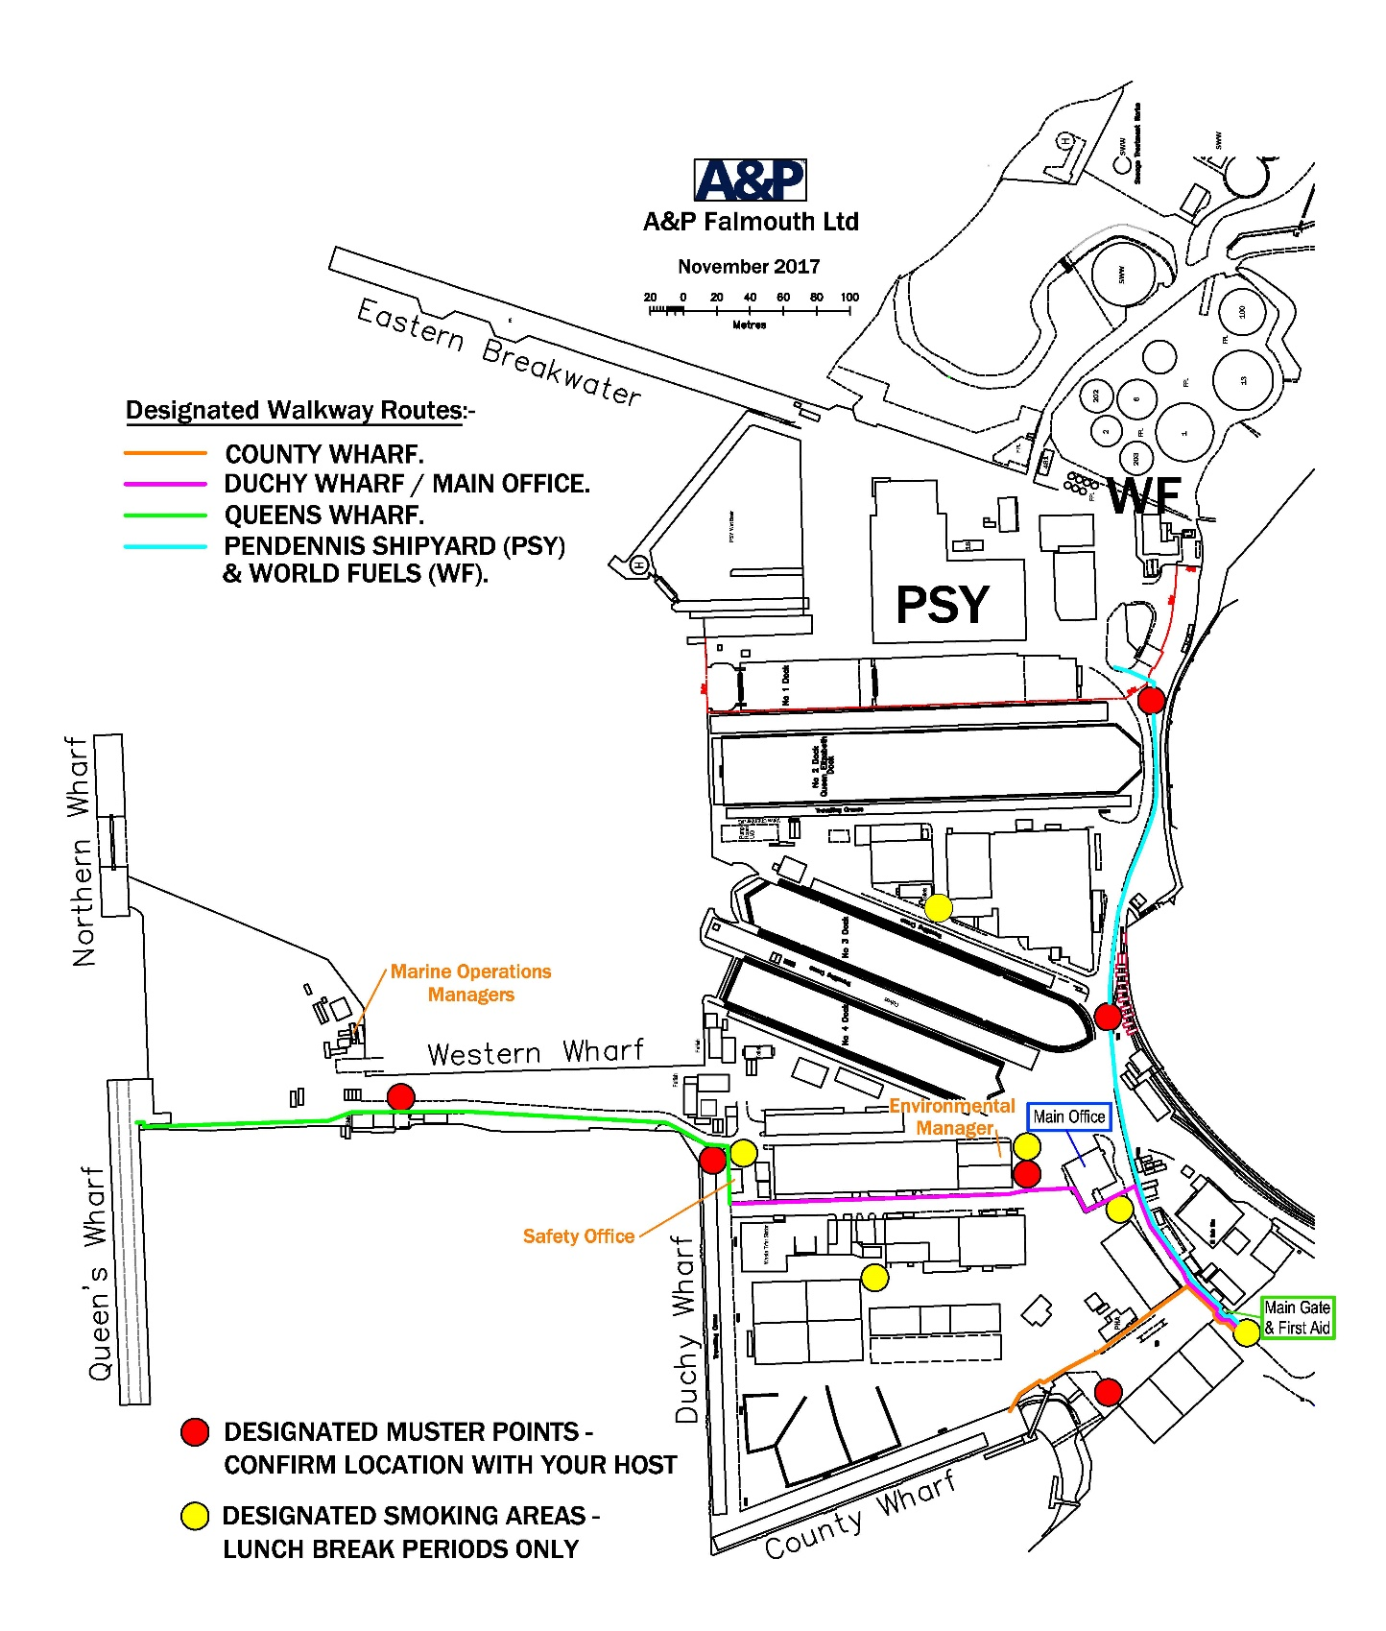

Towage

POC - Port Operations Department +44 (0) 1326 214 666 - mom@ap-group.co.uk

Falmouth Docks and Engineering Company provide vessel towage services within the Dockyard and its approaches. If your vessel makes use of these towage services, please note the following conditions

- All harbour towage operations are undertaken under UK Standard Conditions of towage
- Only safely weighted heaving lines are to be used, any improper heaving lines, will be cut and reported to the MCA
- If towing off a static towline via a quick release hook, please raise and lower all towing lines under control and at a safe speed, DO NOT DROP TOW LINE INTO THE WATER. It places the tug crews at risk when towing lines are dropped or released in an uncontrolled fashion
- Safe speed for connection and disconnection is 4/5knts
- Harbour tugs are permitted to work in 1.5m of swell height, any swell higher than this is subject to special category move.
- Port Towage Guidelines, are available on request from the Port Operations Manger
- Tug lines should be secured to bollards, if a vessel requires to connect into a towing bracket or smit pin, the tug master must be informed

This page intentionally left blank

UNDERTAKING

Vessel Name:  Vessel IMO / Call sign: | Berth:
Vessel Name:  Vessel IMO / Call sign: |  | Please tick
I confirm that I have received, read and accept the "NOTICES TO VESSELS" document. I undertake to comply with this document and to brief my crew in respect of these requirements.
The Ship's ISPS Security State is level:
I ensure that all food contaminated waste is segregated for disposal in the correct skip.
I confirm that I require the following waste disposal facilities: | Skip
 | Slops
 | Other (see below)

Billing Details

Including Address, email, contact No
P&I Club Details

Including, Name, 24hr contact
No of Persons onboard
On arrival

24hr Emergency Contact No
Has a copy of Vessel Fire Plan been provided
Has a Crew List been provided
Has CERS report been provided if required

Masters Name: | Signature: | Date:

Once completed please forward on to Port Operations Department at mom@ap-group.co.uk

Note: Should the vessel change owners or charters this undertaking must be re submitted

